4/6/20 – 4/10/20

**Goals (Where we left off)**

* Read and spell words with short vowels, consonant and digraph blends, bonus letters, and –ng –nk glued sounds. This includes words like *slip, help, song, bank, lunch*.
* Read and spell trick/high frequency words (like *the, is, want, who*)
* Read sentences and passages with fluency and understanding.

**ACTIVITIES:**

* **TRICK/SIGHT WORDS: (Don’t always follow the rules.)**
  + **FLASH CARDS:** Select 3 trick words from the attached list. Start a stack of flash cards with these words on them. Practice reading and spelling these words.

▪▪ Be creative – write with sidewalk chalk, in shaving cream, build with magnetic letters (whatever you have!) – remind your child to spell out loud as they write

* **REGULAR WORDS: (Follow the rules)**
  + **REVIEW:** Work on reading the “review words” quickly and accurately. Cut them out and sort them by vowel. Read each word. Then keep them for review warm-­‐ ups and make your card games!
  + Review glued sounds: https://[www.youtube.com/watch?v=kVknjf9jS_o](http://www.youtube.com/watch?v=kVknjf9jS_o)
  + **Make flashcards with current words** from the word list below. Keep this pile separate from the trick word pile!

▪▪ Use the cards for different sorting activities. This week, sort your cards into the –ng/-­‐nk glued sounds. Read down your list once you’ve sorted them all!

* **SENTENCE READING:** Read the sentences and box the glued sounds! Practice reading the sentences out loud to improve your fluency.
* **STORY READING**: **The Long Song**– notice the glued sounds. Read it out loud and talk about what happened.
* Record a sentence or a part of the story to send to Mrs. Wright!

**Review –ng and –nk glued sounds** – this can be hung up as a reference where students tend to do their school work.

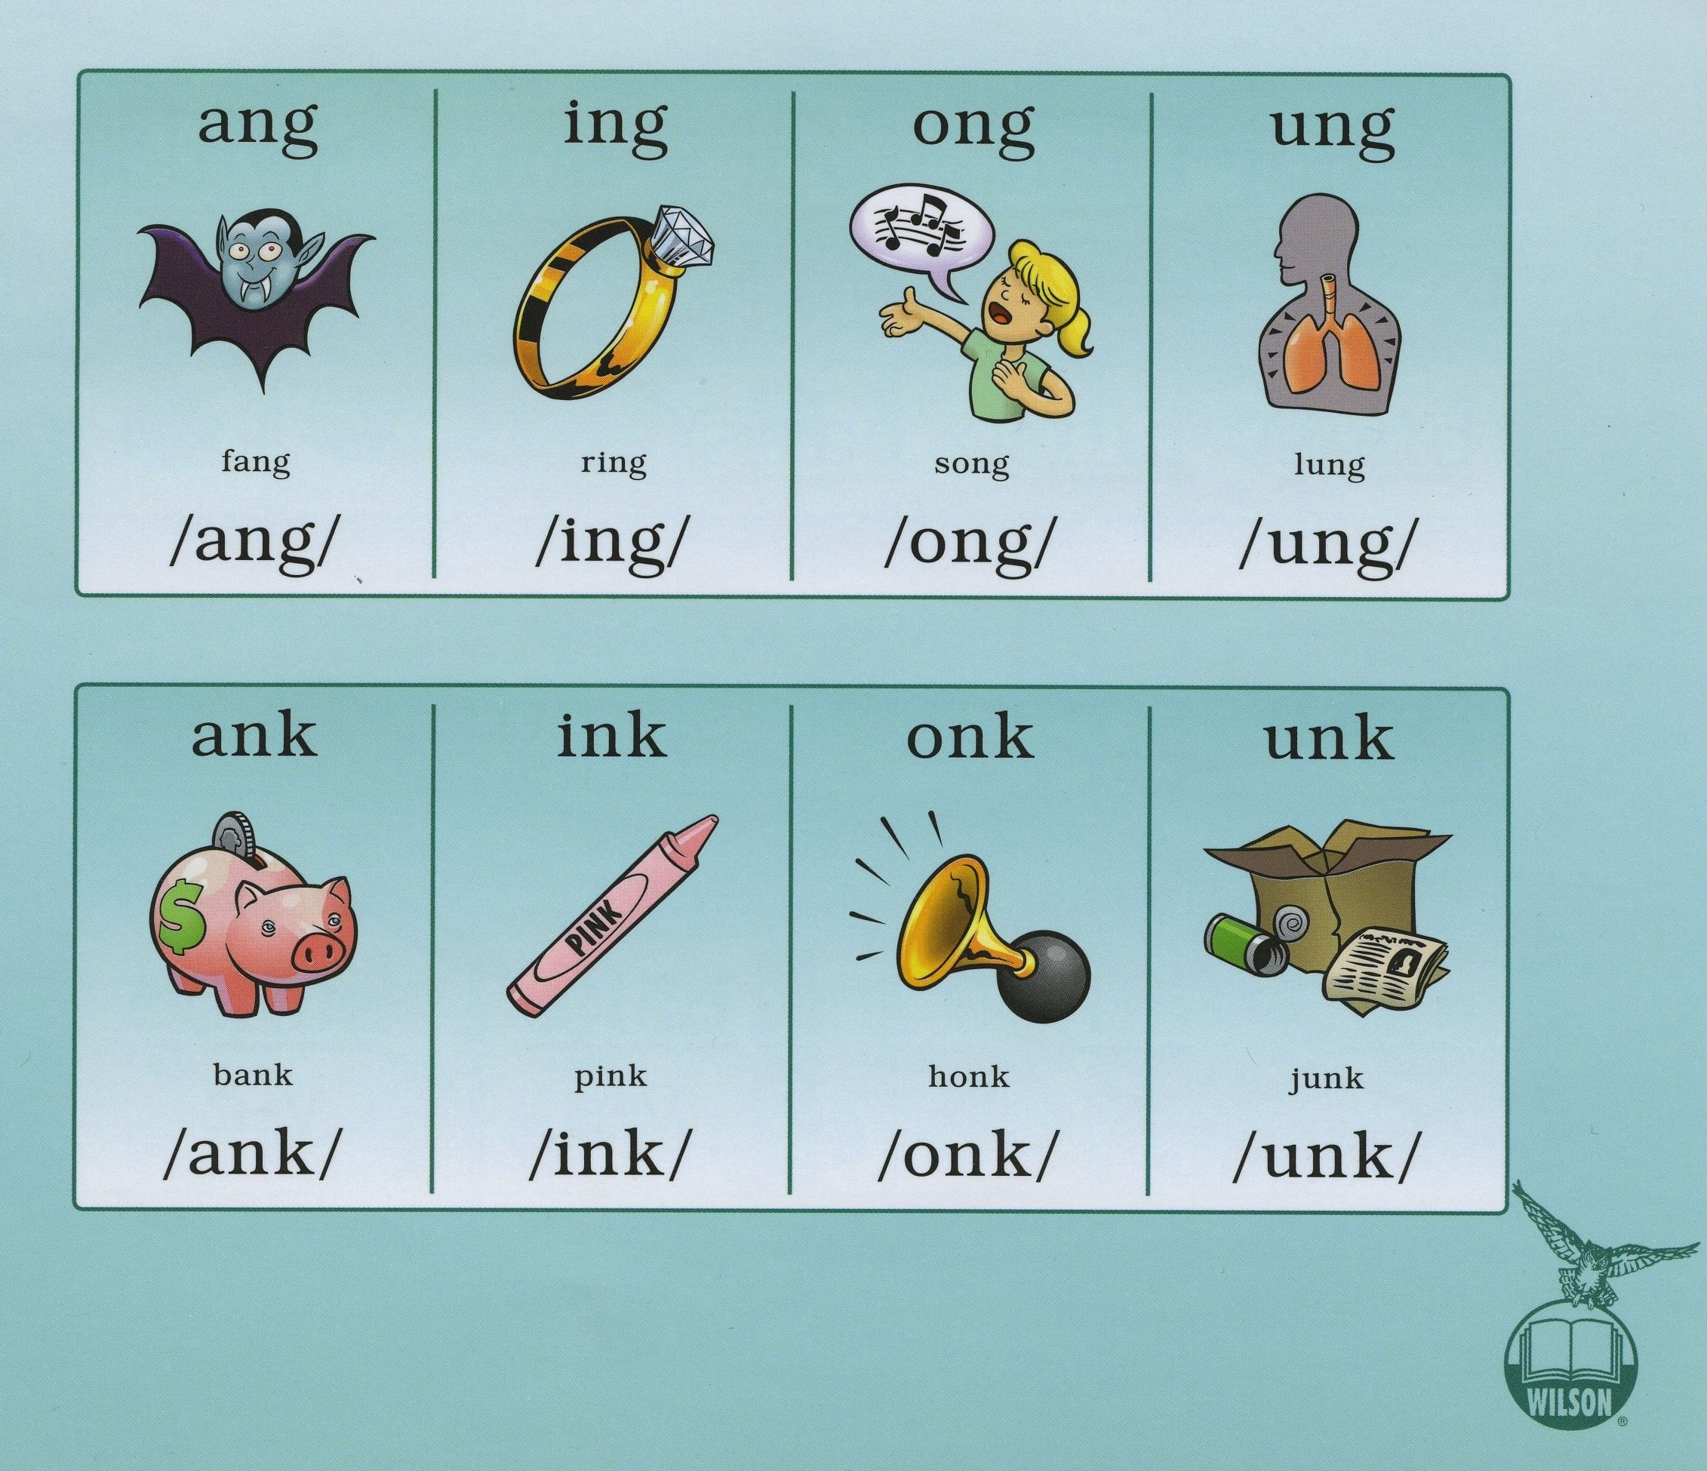

**Word List for Sorting & Flashcards**

|  |  |  |
| --- | --- | --- |
| bang | fang | rang |
| sang | bank | thank |
| tank | rink | sink |
| think | thing | sing |
| ring | song | long |
| gong | honk | bonk |
| sung | lung | hung |
| junk | bunk | sunk |

**Read the sentences. Box glued sounds! Repeat reading to improve fluency. Sketch a picture to go with sentences. (This is not expected to be done in one sitting.)**

1. Tom sang the song to the kids.
2. Get the ping-pong balls.
3. It is a long run up the hill.
4. Kim will sing at the shop.
5. The ring did not fit Meg.
6. What is the thing in this jug?
7. Ed sank the shot to win!
8. The wings on the bug are pink.
9. The ship sank in the bathtub.
10. My cash is in the bank.