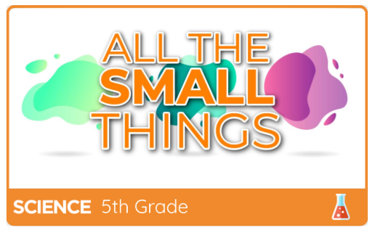 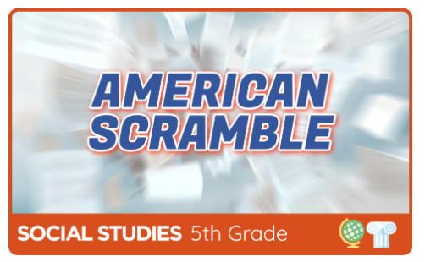 

Breakout EDU is an online platform where students and families work together to solve various puzzles to open a locked box, similar to an escape room. In the suggested “ assigned games list”, you'll find games on geometric shapes, literature, physical education, computer science, and the library, and even team development. Remember that the goal of these escape room activities is to keep participants focused on building the critical-thinking and social and emotional skills necessary to solve these complex problems and… to have fun ☺ !!!!!!

|  |  |  |  |  |  |  |  |  |  |  |  |  |  |  |  |  |  |  |  |  |  |  |  |  |
| --- | --- | --- | --- | --- | --- | --- | --- | --- | --- | --- | --- | --- | --- | --- | --- | --- | --- | --- | --- | --- | --- | --- | --- | --- |
| How to sign into game   1. Go to student.breakoutedu.com 2. Login using **Breakout EDU** 3. Use one of the following usernames and passwords  |  |  | | --- | --- | | Username | Password | | Student F | student | | Student G | student | | Student H | student | | Student I | student | | Student J | student |  |  |  | | --- | --- | | Username | Password | | Student A | student | | Student B | student | | Student C | student | | Student D | student | | Student E | student |  1. Click on Class 4 2. Choose one of the assigned games on the list and click **Play**. 3. Read general story and begin. 4. Use the game explanation and answers in this guide to give clues if needed. |

**\*\* If for some reason a user name and password doesn’t work… please select another one from the list\*\***