**Name: ____________________________ Date: ___________**

**Place Value: Big Ideas**

* A **digit** is any one of the symbols **0, 1, 2, 3, 4, 5, 6, 7, 8** and **9** that are used to write numbers.
* The **place**, (the position of a digit in a larger number), affects the **value,** (worth, *think*: $$$), of the digit.

***Example:*** 2,356,784

The digit “5” is in the _____________________ **place**.

The digit “5” has a **value** of ________________.

* As you move along a place value chart **from the right to the left**, the value of each place is ten times greater than the value of the place to its right

***Example:*** 400

40

4

4 hundreds is 10x greater than 4 tens

4 tens is 10x greater than 4 ones

* As you move along a place value chart **from the left to the right**, the value of each place is ten times less than the value of the place to its left.

***Example:*** 400

40

4

4 ones is 10x less than 4 tens

4 tens is 10x less than 4 hundreds

X 10

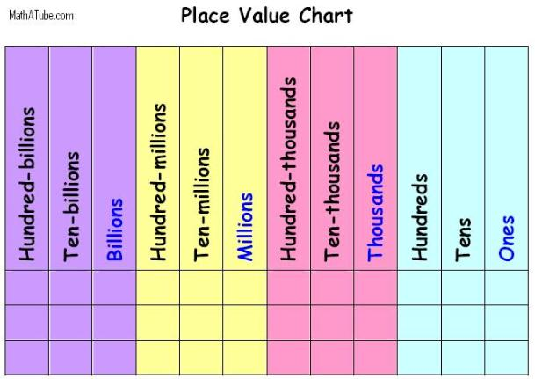

÷10

**Three Forms of Numbers**

* **Word Form:** a number written using **words**
* **Standard Form:** a number written using digits
* **Expanded Form:** a number written, which shows the value of each individual digit

(beginning with the largest place)

***Example:***

* **Word Form:** four million, three hundred twenty-nine thousand, eight hundred fifty-seven.
* **Standard Form:** 4,329,857
* **Expanded Form:** 4,000,000 + 300,000 + 20,000 + 9,000 + 800 + 50 + 7

**Comparing and Rounding**

**Comparing:**

* Start at the largest place and move to the right, comparing each digit, one at a time.
* Use <, >, or = to compare numbers (example: 3,498,109 **<** 4,582,302)

**Rounding:**

* Carefully read and follow the directions…so as to know to which “given” place, (in the place value chart…), you’re rounding. (**Underline** the digit that is in that “given” place.)
* What are the benchmark numbers? What is the midpoint number?
* Think of a number line: would you plot your point to the left or to the right of your midpoint number? Whichever benchmark number your original number is closer to, you’d round to. Is your original number ***less than the midpoint number***? (“Round down.”) Is your original number ***greater than or equal to the midpoint number?*** (“Round up.”);
* if the “boxed” digit is 0, 1, 2, 3, or 4…the underlined digit stays the same…and all digits to the RIGHT of that underlined digit become zero.
* if the “boxed” digit is 5, 6, 7, 8, or 9…the underlined digit “rounds up,” …and all digits to the RIGHT of that “rounded up” digit become zero.

***Example:*** Round 27,923 to the nearest thousands.

Steps to solve:

* underline the digit in the thousands place, (“7”), and “box” the digit in the hundreds place, (“9”). 27,923
* benchmark numbers: 27,000 and 28,000;
* midpoint number: 27,500;
* 27,923 > 27,500, so it rounds to…
* 28,000

27,000 27,500 27,923 28,000